Software Requirements Specification
for
SE Project

Prepared by

Omkar Londhe 202301040027

Yashraj Jagtap 202301040092

Ishwari Mahajan 202301040173

Om Thorat 202301040155

Sumit Khetre 202402040017

Sneha Nannaware 202301040267

MIT Academy of Engineering

Enhancing Company Registration Security Using Real-Time Camera-Based Age and Gender Verification

Index
- Introduction
  - Purpose
  - Document Conventions
  - Intended Audience and Reading Suggestions
  - Product Scope
  - References

Overall Description
  - Product Perspective
  - Product Functions
  - User Classes and Characteristics
  - Operating Environment
  - Design and Implementation Constraints
  - User Documentation
  - Assumptions and Dependencies

External Interface Requirements
  - User Interfaces
  - Hardware Interfaces
  - Software Interfaces
  - Communications Interfaces

Other Nonfunctional Requirements
  - Performance Requirements
  - Safety Requirements
  - Security Requirements
  - Software Quality Attributes
  - Business Rules

Other Functional Requirements
  - Database Requirements
  - Internationalization Requirements
  - Legal C Compliance Requirements
  - Reusability Objectives

- UML Diagrams

Introduction

Purpose
The purpose of this project is to enhance security in company registration processes by implementing a real-time camera-based age and gender verification system. This system aims to prevent fraudulent entries by ensuring that only authentic users can register. The software leverages artificial intelligence (AI) and machine learning (ML) techniques to analyze the captured images and verify the user's age and gender in real time.
The key objectives of the system are:
    - To enhance security by reducing fraudulent registrations.
    - To automate identity verification using AI-based age and gender detection.
    - To integrate seamlessly with existing company registration portals without requiring major modifications.
    - To provide an intuitive user experience, ensuring smooth interaction with the verification system.
This document outlines the functional and non-functional requirements of the software, providing detailed insights into its scope, design considerations, and references.

Document Conventions
This document follows standard conventions and formatting practices, ensuring clarity and consistency. Below are the key conventions followed:
    - Technical terms and keywords are highlighted in bold.
    - UML diagrams such as Use Case Diagrams, Class Diagrams, and Sequence Diagrams are used for system modeling.
    - The software follows modular architecture, ensuring ease of scalability and integration.
    - Artificial Intelligence (AI) models are employed for detecting user attributes.
    - Security protocols and encryption methods are used to safeguard sensitive data.
    - References are cited in IEEE format to maintain standard academic integrity.

Intended Audience and Reading Suggestions
This document is intended for different types of stakeholders involved in the project. The content is structured to be relevant for:

Software Developers:
      - To understand the technical implementation of the AI-based verification system.
      - To develop and optimize algorithms for accurate age and gender detection.

Project Managers:

      - To monitor the development progress and ensure that security goals are met.
      - To assess project feasibility and system integration.

Users s Business Owners:
      - To ensure seamless user experience and compliance with security requirements.
      - To minimize fraudulent activities in registration processes.

Testers s Quality Assurance (QA) Engineers:
      - To validate the accuracy and efficiency of the AI model.
      - To conduct performance testing for real-time verification.

Suggested Reading Flow:
- Introduction: Understand the problem statement and system goals.
- Product Scope: Overview of system features and capabilities.
- Requirement Specification: Detailed system requirements.
- System Diagrams: Structural and behavioral design representation.
- References: External resources used in research and development.

Product Scope
The real-time age and gender verification system is designed to enhance security in company
registration processes by preventing fraudulent entries. The system integrates computer vision, deep learning, and AI-based biometric authentication to verify users accurately.

Key Features of the System:
    - Real-Time Image Capture:
      - The system automatically activates the camera when a user attempts to register.
      - It captures a clear image of the user for further processing.

AI-Based Age and Gender Detection:
      - A machine learning model analyzes the captured image to predict the user’s age and gender.
      - The system cross-verifies the detected attributes with the user-provided details.

Seamless Integration with Registration Portals:
      - The system is designed to integrate easily with existing registration platforms.
      - API-based implementation ensures smooth communication between the verification system and company databases.

User-Friendly Interface:
      - The system provides a simple and interactive UI for users.

      - The interface ensures minimal manual intervention, making the process efficient and secure.

Business Goals and Benefits:
    - Reduces fraudulent registrations by ensuring accurate identity verification.
    - Enhances compliance with regulations that require verification of age and identity.
    - Improves the user experience by offering a smooth and automated verification process.
    - Increases operational efficiency by automating identity verification, reducing the need for manual intervention.

References
The system design and implementation are based on the latest research in AI-driven facial recognition and verification. The following references provide insights into the technologies and methodologies
used:
- J. Brownlee, “How to Perform Face Detection with Deep Learning,” Machine Learning Mastery, Jun. 02, 2019.
  - This paper provides an in-depth analysis of deep learning techniques for facial recognition.
- S. Manasa, J. S. Abraham, A. Sharma, and K. Himapoornashree, “Age, gender and emotion detection using CNN,” International Journal of Advanced Research in Computer Science, vol. 11, no. Special Issue 1, p. 68, 2020.
  - This research discusses the implementation of convolutional neural networks (CNN) for detecting age, gender, and emotions.
- A. Voulodimos, N. Doulamis, A. Doulamis, and E. Protopapadakis, “Deep Learning for Computer Vision: A Brief Review,” Computational Intelligence and Neuroscience, Feb. 01, 2018.
  - This paper reviews the application of deep learning in computer vision and biometric authentication.
- L. Boureau, J. Ponce, and Y. LeCun, “A Theoretical Analysis of Feature Pooling in Visual Recognition,” 2010.
  - This study provides insights into image feature pooling techniques for facial recognition.
- O. Agbo-Ajala and S. Viriri, “Deeply learned classifiers for age and gender predictions of unfiltered faces,” The Scientific World Journal, vol. 2020, 2020.
  - The paper explores the use of deep learning classifiers for predicting the age and gender of individuals.

Overall Description

Product Perspective
The real-time camera-based age and gender verification system is a new, standalone product
designed to enhance the security of company registration processes. It integrates seamlessly with existing registration portals and automates the identity verification process, reducing fraudulent registrations.
This product is not a replacement for any existing system but acts as an add-on security layer to improve authentication accuracy. The system consists of the following key components:
    - User Interface (UI): Allows users to interact with the verification system.
    - Camera Module: Captures real-time images during registration.
    - AI Model: Detects age and gender based on the captured image.
    - Database: Stores and manages verification logs for future audits.
    - API Integration Layer: Connects with company registration portals to facilitate seamless verification.

System Architecture Overview (Simplified Diagram)
[User] → [Camera Module] → [AI Model] → [Verification Engine] → [Registration Portal]
    - User: Initiates registration.
    - Camera Module: Captures the image.
    - AI Model: Analyzes the image to determine age and gender.
    - Verification Engine: Matches the AI result with the user’s provided details.
    - Registration Portal: Confirms identity verification and completes registration.

Product Functions
The system provides the following major functions:

Real-Time Camera Capture:
  - Automatically activates the camera when a user begins registration.
  - Captures a clear image for identity verification.

AI-Based Age s Gender Verification:
  - Uses machine learning (ML) models to detect the user’s age and gender.
  - Ensures accuracy by cross-checking the detected values with user-provided details.

Seamless Integration with Registration Systems:
  - Provides APIs to integrate with existing registration portals.
  - Allows companies to validate user identities in real-time.

Fraud Prevention s Security Measures:
  - Flags mismatched age or gender details for manual verification.
  - Stores logs securely for future audits and compliance tracking.

User-Friendly Interface:
  - Ensures a smooth, intuitive experience for all users.
  - Provides error handling and real-time feedback.

User Classes and Characteristics
The system is designed for different user classes, each with specific roles and requirements:

General Users (Applicants):
  - Who: Individuals registering for a company.
  - Usage: Uploads ID details and completes the verification process.
  - Characteristics: Non-technical users; require a simple and intuitive interface.

Business Administrators:
  - Who: Registration officers verifying applications.
  - Usage: Reviews flagged applications for manual verification.
  - Characteristics: Moderate technical knowledge; requires dashboard access.

System Administrators:
  - Who: IT personnel managing system performance.
  - Usage: Monitors AI model accuracy, system logs, and API performance.
  - Characteristics: Highly technical users; require access to system settings.

Compliance Officers:
  - Who: Government or legal authorities ensuring security compliance.
  - Usage: Audits verification logs for compliance with identity regulations.
  - Characteristics: Non-technical users; need read-only access.

Operating Environment
The software is designed to run in the following environment:

Hardware Requirements:
    - Camera: HD camera with at least 720p resolution for accurate verification.

    - Processor: Minimum Intel i5 / Ryzen 5 (or higher) for AI processing.
    - RAM: 8GB or higher.
    - Storage: 50GB available space for logs and model storage.

Software Requirements:
    - Operating System: Windows 10/11, Linux (Ubuntu, Fedora), macOS.
    - Database: MySQL / PostgreSQL / MongoDB for verification logs.
    - Programming Language: Python (for AI model), JavaScript (for front-end).
    - Machine Learning Library: TensorFlow / PyTorch for age and gender detection.
    - Web Server: Apache / Nginx for hosting the web interface.

Network Requirements:
    - Internet Connectivity: Required for API integration and cloud-based processing.
    - Secure Communication: Uses HTTPS and TLS encryption for secure data transfer.

Design and Implementation Constraints
Several constraints and limitations may affect system design and implementation:

Regulatory s Compliance Constraints:
  - Must comply with data privacy laws (GDPR, CCPA).
  - User images must be encrypted and not stored without consent.

Hardware Limitations:
  - The accuracy of age and gender detection depends on camera quality.
  - May require dedicated GPUs for real-time processing.

Software s Integration Constraints:
  - The system must integrate with different registration platforms without modifications.
  - AI model accuracy may vary based on lighting conditions and image clarity.

Performance Constraints:
  - The system must verify a user’s age and gender within 2-3 seconds.
  - High-traffic environments may require cloud-based AI processing.

User Documentation
The following documentation will be provided with the software:

User Manual:

  - Step-by-step guide on using the verification system.
  - Instructions on capturing images and troubleshooting common errors.

API Documentation:
  - Provides details on integrating the verification system with existing platforms.
  - Includes API endpoints, authentication methods, and response formats.

Installation Guide:
  - Describes system requirements and setup procedures.
  - Includes guidance for local installation and cloud-based deployment.

Technical Documentation:
  - Explains the AI model, system architecture, and database schema.
  - Intended for developers maintaining or improving the system.

Assumptions and Dependencies
Several assumptions and dependencies exist that could impact system performance:

Assumptions:
    - Users will have a working camera for real-time image capture.
    - AI models will be trained on diverse datasets to improve accuracy.
    - Companies using the system will have an internet connection for API calls.
    - Facial recognition will not be blocked due to privacy restrictions in certain regions.

Dependencies:
    - Third-Party AI Libraries: Uses TensorFlow/PyTorch for deep learning.
    - Cloud Computing Services: May use AWS/GCP/Azure for AI model deployment.
    - Camera Hardware: Performance depends on camera resolution and frame rate.
    - Legal Compliance: System depends on government policies on biometric verification.

External Interface Requirements

User Interfaces
The user interface (UI) of the system is designed to be intuitive, simple, and user-friendly, ensuring a smooth user experience. The interface consists of:

Key UI Components:
- Login s Registration Screen:
  - Users enter basic registration details before proceeding to verification.
  - A “Start Verification” button initiates real-time camera capture.

Camera Capture Screen:
  - The system automatically activates the camera.
  - A "Capture Image" button is available if auto-capture fails.
  - A real-time preview window allows users to adjust their position.
  - Error messages displayed for issues like low lighting or face not detected.

Verification Results Page:
  - Displays detected age and gender with a comparison to user-provided details.
  - If details do not match, a warning message appears:
    - "Your provided details do not match the detected attributes. Please verify your identity."
  - If verification is successful, a success message appears:
    - "Identity verified successfully. Proceed with registration."

Admin Dashboard:
  - Displays logs of verified users.
  - Provides options to review flagged registrations.
  - Allows system administrators to configure AI models and manage security settings. GUI Standards s Guidelines:
- Consistency: All screens follow the same design theme.
- Accessibility: UI is color-blind friendly and supports screen readers.

Standard Buttons:
  - "Capture Image" - Captures a new image.
  - "Retry" - Restarts the verification process.
  - "Proceed" - Moves to the next step after successful verification.

Keyboard Shortcuts:
  - Enter – Confirm selection.
  - Esc – Cancel the current action.

Hardware Interfaces
The system interacts with hardware components for real-time image capture and processing. Supported Hardware:

Web Cameras:
      - Supports built-in laptop webcams and external USB cameras.
      - Minimum resolution: 720p (for accurate face detection).
      - Recommended resolution: 1080p or higher.

Processing Units:
      - Works on CPU-based processing, but GPU acceleration is recommended for faster AI computations.
      - Supported GPUs:
        - NVIDIA CUDA-enabled GPUs (e.g., RTX 2060 or higher).
        - AMD Radeon GPUs (with ROCm support).

Storage Requirements:
      - Verification logs and images require at least 50GB of available disk space.

Peripheral Devices:
      - Supports USB fingerprint scanners (optional, for multi-factor authentication).

Data Flow Between Software s Hardware:
- User starts verification → Software activates camera.
- Camera captures image → Image is sent to AI model for analysis.
- AI model predicts age s gender → Result is displayed on UI.
- Data is stored in the database → Flagged entries are marked for manual review.

Software Interfaces
The system integrates with various software components for image processing, AI-based verification, and database management.

Operating System Compatibility:

    - Windows 10/11 (64-bit)
    - Linux (Ubuntu 20.04+, Fedora)
    - macOS Monterey+

Databases:
    - MySQL / PostgreSQL (Stores user verification logs).
    - MongoDB (For NoSQL-based storage).

Programming Languages s Frameworks:
    - Backend: Python (Flask/Django for API development).
    - Frontend: HTML, CSS, JavaScript (React/Angular for UI).

Machine Learning:
      - TensorFlow / PyTorch (AI model for age C gender detection).
      - OpenCV (Image processing).

API s Software Components:

Component | Purpose
Face Recognition API | Detects and verifies user identity
AI Model (TensorFlow/PyTorch) | Predicts age and gender
RESTful API Layer | Connects the system with registration portals
Database API (SQL/NoSQL) | Stores verification logs
Encryption Module | Secures user data with AES encryption

Data Flow s Communication Between Software Components:
- User registers → UI sends data to backend server.
- Backend server → Calls AI model via ML framework (TensorFlow/PyTorch).
- AI model processes the image → Returns age and gender prediction.

Backend cross-checks → Stores logs in the database.
- If mismatch is detected, the system flags the entry for manual review.

Communications Interfaces
The system requires secure communication between the verification software, registration portals, and AI models.

Network Protocols Used:
    - HTTPS (TLS 1.2/1.3): Ensures secure data transmission.
    - WebSockets: Used for real-time communication between UI and backend.
    - RESTful APIs: Enables integration with third-party registration portals.

Message Formatting Standards:
    - JSON: Used for API request/response.
    - XML (optional): If required by third-party systems.

Authentication s Security Mechanisms:
    - OAuth 2.0 / JWT (JSON Web Token): For user authentication.
    - AES-256 Encryption: Protects sensitive data.
    - Secure Hashing Algorithm (SHA-256): Used for password protection.

Other Nonfunctional Requirements

Performance Requirements
The system is designed to deliver high accuracy, fast response time, and seamless integration for real- time age and gender verification. The following performance criteria must be met:

Response Time:
    - The AI model must process images and return results within 2-3 seconds.
    - The camera activation and image capture should occur within 1 second of initiating verification.
    - The registration system integration should complete within 5 seconds.

Accuracy s Reliability:
    - The age detection accuracy should be above 90%.
    - The gender classification accuracy should be above 95%.
    - The system should handle up to 100 concurrent verifications without performance degradation.

Load Handling s Scalability:
    - The system must support 500+ verifications per hour in high-traffic conditions.
    - The AI processing module should scale horizontally to support additional workload using cloud-based GPU instances.
    - The database should process at least 1000 read/write transactions per second (TPS) for efficient storage and retrieval.

System Availability:

    - The system should maintain 99.9% uptime to ensure continuous availability.
    - Automatic failover mechanisms should be implemented for uninterrupted service.

Safety Requirements
The system is designed to minimize risks related to data privacy, hardware failures, and incorrect verifications.
Data Privacy C Protection:
    - No image data is stored permanently unless explicitly required by legal authorities.
    - All verification logs are encrypted before being saved in the database. Failure Handling C Error Recovery:
    - If face detection fails, users will be given an option to retry with better lighting conditions.
    - If AI-based age or gender detection is inconclusive, the system must flag the user for manual review.
    - If the camera malfunctions, users should be able to upload a pre-captured image securely. Compliance with Regulations:
    - The system must comply with GDPR (General Data Protection Regulation) for handling user data.
    - Age-restricted businesses using the system must ensure compliance with COPPA (Children’s Online Privacy Protection Act).

Security Requirements
Security is a critical aspect of the verification system, as it deals with sensitive user data and biometric authentication.

Authentication s Authorization:
    - OAuth 2.0 / JWT (JSON Web Token) will be used for secure authentication.
    - Role-Based Access Control (RBAC) ensures that only authorized users (e.g., admin, compliance officers) can access verification logs.

Data Encryption s Protection:
    - All data transmissions will be secured using TLS 1.3 encryption.
    - User images will be hashed using SHA-256 before being stored temporarily.
    - The system must automatically delete stored images after processing.

Intrusion Prevention s Logging:
    - Firewall and intrusion detection systems will prevent unauthorized access.
    - All failed login attempts and security breaches will be logged and reported.

API Security:
    - API access must be restricted using API keys and rate limiting.
    - CORS (Cross-Origin Resource Sharing) policies should be enforced to prevent unauthorized API usage.

Software Quality Attributes
The software must adhere to high-quality standards to ensure efficiency, security, and reliability.

Attribute | Requirement
Availability | 99.9% uptime guarantee.
Scalability | Supports high traffic (500+ verifications per hour).
Accuracy | 90%+ accuracy in age detection, 95%+ accuracy in gender classification.
Interoperability | Can integrate with various registration platforms via APIs.
Security | Complies with GDPR, COPPA for user data protection.
Reliability | Automatic failover in case of server failure.
Usability | User-friendly UI with real-time feedback.
Portability | Compatible with Windows, Linux, macOS.

Business Rules
The system follows specific rules to ensure compliance with security policies and company registration requirements:

Identity Verification Rule:
  - The detected age and gender must match the user-provided details.
  - If discrepancies are detected, the system flags the entry for manual review.

Data Retention Rule:
  - Verification data is stored temporarily and deleted after processing.
  - Only registration officers and compliance teams can access flagged data.

User Authentication Rule:
  - Users must log in via multi-factor authentication (MFA) before accessing verification results.
  - Admins have restricted access based on their roles.

Fraud Prevention Rule:

  - If a user attempts multiple failed verifications, their account is temporarily blocked for 24 hours.
  - AI-based anti-spoofing measures prevent verification using fake images or videos.

Other Functional Requirements

Database Requirements:
    - The system should use a relational database (MySQL/PostgreSQL) for structured data storage.
    - MongoDB (NoSQL) can be used for storing logs and unstructured data.
    - Data must be encrypted at rest using AES-256 encryption.

Internationalization Requirements:
    - The system should support multiple languages for global users.
    - Date, time, and currency formats should be configurable based on user locale settings.

Legal s Compliance Requirements:
    - The system must comply with GDPR, COPPA, and local biometric data laws.
    - All data privacy policies must be clearly communicated to users.

Reusability Objectives:
    - The AI model should be reusable for other biometric authentication tasks.
    - The API layer should be modular and adaptable for future identity verification solutions.

UML Diagrams
  - Use Cse Diagram
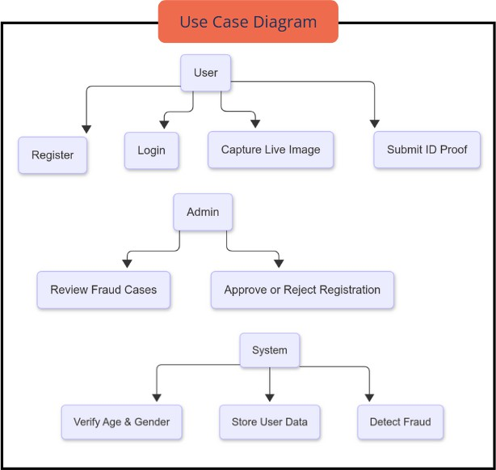

  - Object Diagram
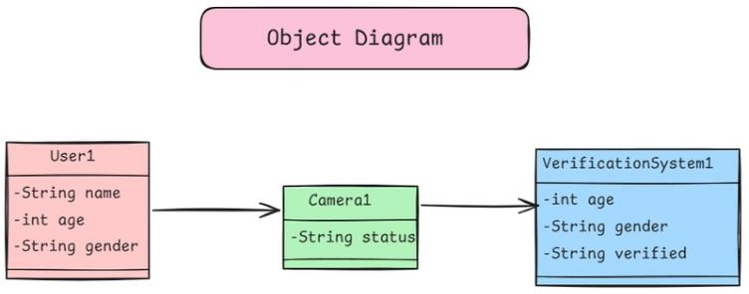

  - Deployment Diagram
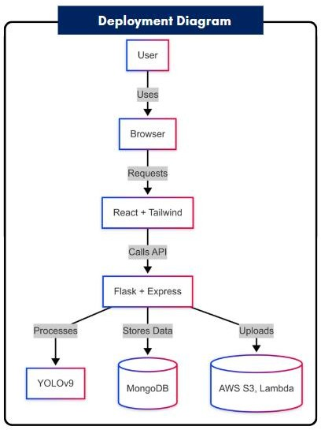

  - Time Diagram

